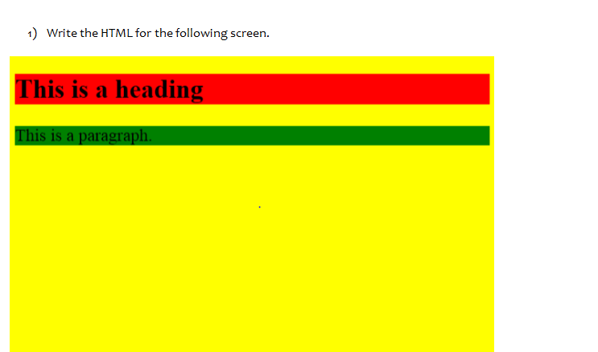

<html>

<head>

    <title> Learning Html</title>

</head>

<body bgcolor="yellow">

    <h1 style="color:red">This is a heading</h1>

    <p style="color:green">This is a paragraph</p>

</body>

</html>

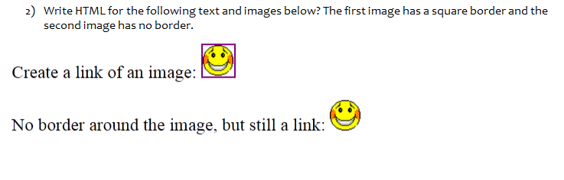

<html>

<head>

    <title> Learning Html</title>

</head>

<bodY>

    <img src="picture.jpeg">

</body>

</html>

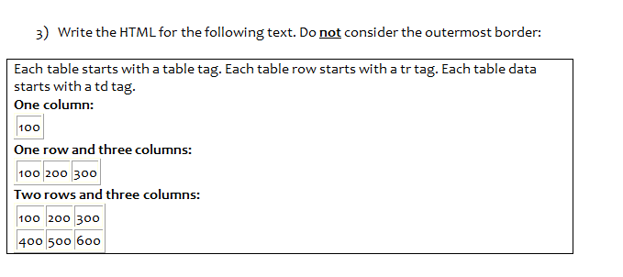

<html>

<head>

    <title> Learning Html</title>

</head>

<bodY>

    <table border=3>

        <tr>

            <td>100</td>

        </tr>

        <tr >

            <td>100</td>

            <td>200</td>

            <td>300</td>

        </tr>

        <tr>

            <td>100</td>

            <td>200</td>

            <td>300</td>

        </tr>

        <tr>

            <td>400</td>

            <td>500</td>

            <td>600</td>

        </tr>

    </table>

</body>

</html>

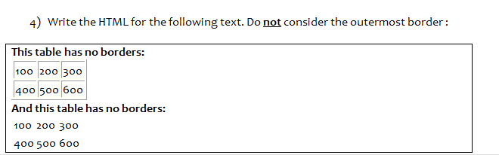

<html>

<head>

    <title> Learning Html</title>

</head>

<bodY>

    <table border=3>

        <caption>This tables has borders:

        </caption>

        <tr >

            <td>100</td>

            <td>200</td>

            <td>300</td>

        </tr>

        <tr>

            <td>400</td>

            <td>500</td>

            <td>600</td>

        </tr>

        </table>

        <table>

            <caption>This table has no borders:</caption>

        <tr>

            <td>100</td>

            <td>200</td>

            <td>300</td>

        </tr>

        <tr>

            <td>400</td>

            <td>500</td>

            <td>600</td>

        </tr>

    </table>

</body>

</html>

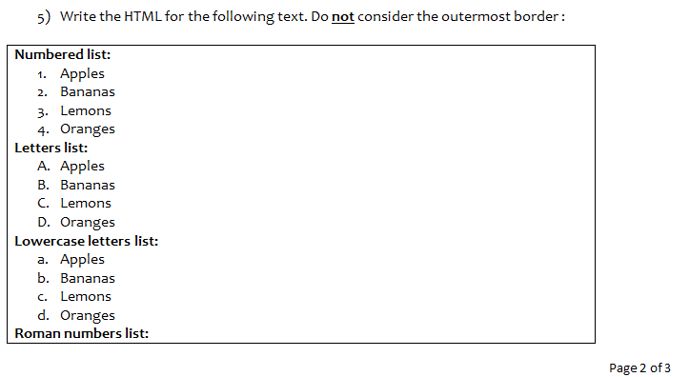

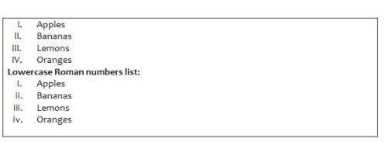

<html>

<head>

    <title> Learning Html</title>

</head>

<body>

    <caption>Numbered list:</caption>

    <ol type:"1">

        <li>Apples</li>

        <li>Bananas</li>

        <li>Lemons</li>

        <li>Oranges</li>

    </ol>

    <caption>Letters list:</caption>

    <ol type:"A">

        <li>Apples</li>

        <li>Bananas</li>

        <li>Lemons</li>

        <li>Oranges</li>

    </ol>

    <caption>Lowercase letters list:</caption>

    <ol type:"a">

        <li>Apples</li>

        <li>Bananas</li>

        <li>Lemons</li>

        <li>Oranges</li>

    </ol>

    <caption>Roman numbers list:</caption>

    <ol type:"I">

        <li>Apples</li>

        <li>Bananas</li>

        <li>Lemons</li>

        <li>Oranges</li>

    </ol>

    <caption>Lowercase Roman numbers list:</caption>

    <ol type:"i">

        <li>Apples</li>

        <li>Bananas</li>

        <li>Lemons</li>

        <li>Oranges</li>

    </ol>

</body>

</html>

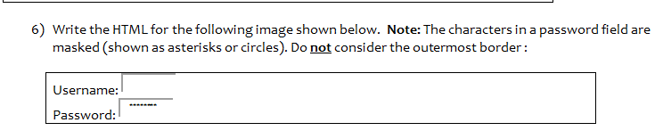

<html>

<head>

    <title> Learning Html</title>

</head>

<body>

    <form>

    <label>Username:</label>

    <input type="text"/><br>

    <label>Password:</label>

    <input type="password"/>

    </form>

    </body>

</html>

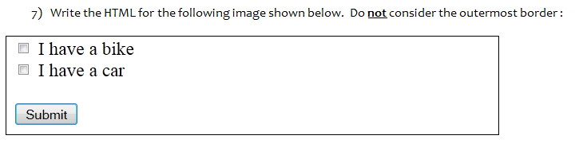

<html>

<head>

    <title> Learning Html</title>

</head>

<body>

    <input type="checkbox">

    <label> I have a bike</label><br>

    <input type="checkbox">

    <label> I have a car</label><br>

    <input type="submit"value="submit">

</body>

</html>

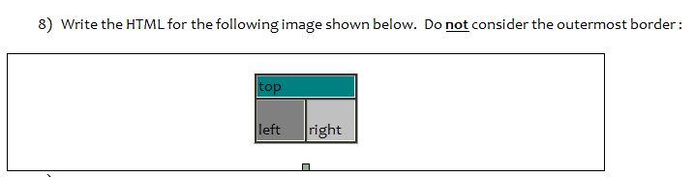

<html>

<head>

    <title> Learning Html</title>

</head>

<body>

    <table style="border:2">

        <tr row span="2" style="bgcolor:green">

            <th>top</th>

        </tr>

        <tr style="border:2">

            <td style="border:2;"background-color:lightslategrey">Left</td>

            <td style="border:2;"background-color:darkgrey">Right</td>

        </tr>

    </table>

</body>

</html>

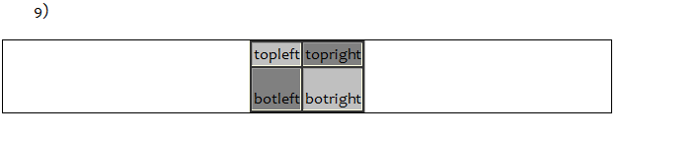

<html>

<head>

    <title> Learning Html</title>

</head>

<body>

    <table style="border:2">

        <tr row span="2" style="bgcolor:grey">

            <th>topleft</th>

            <th>topright</th>

        </tr>

        <tr style="border:2">

            <td style="border:2;"background-color:lightslategrey">botleft</td>

            <td style="border:2;"background-color:darkgrey">botright</td>

        </tr>

    </table>

</body>

</html>